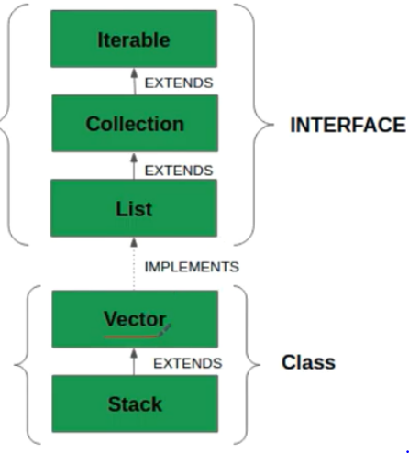

**Vectors with ArrayList**

**Question -Can we add vectors with some other collection?**

Ans –Yes we can do that.

Generally we don't use vector, because it is a synchronized. every method of vector is synchronized. It means at a time only one thread can access that either you want to add the value or you want to get

the value. So

2

Example ---

This is a Vector object

1

3

In this particular vector object. And there are multiple threads are there. They're trying to add the values over here.

If once thread Number 1 add the value in the particular vector object, Then 2 or 3 number of thread cannot access to the vector object. Because they all are synchronized but in case of Arraylist

they can access the value, they can add the value, they can update the value but in case of vector it is not possible. Because if one thread is working then another thread cannot work.it will provide a lock over. This thread will be locking this entire object once the thread work is done.

and once the thread is killed then only another object will enter and then get the value or update the value or write the value accordingly.

if multiple threads are trying to access ,it will give you concurrent modification exception over here.

===================================================================

Question - How to create 2d vector?

Ans-- 2D vector it means vector inside a vector. A 2d vector is a vector that has each of its element, is also a vector . So you can say vector of vectors.

----------------------------------------

so i'll create a separate class for that

11:47

so let me quickly create a class

11:49

and i'm simple right let's see a

11:52

vector 2d concept

11:56

okay select the main method click on

11:58

finish

11:59

and what i'm going to do that i'm going

12:02

to add let's see this time

12:04

adding some values over here i'm

12:07

creating a vector

12:07

and this time using string type of

12:09

values and

12:12

let's see this is my first vector is

12:16

equal to

12:16

new vector okay or i give a proper name

12:20

this is my

12:21

let's see language vector language

12:24

vector

12:24

and this is also taking okay import this

12:27

particular vector from java.util package

12:29

and language vector i'm going to add

12:32

multiple programming languages

12:34

let's see i'm adding java so let's say

12:37

i'm adding uh

12:38

python i'm adding a ruby

12:41

i'm adding java a script

12:44

and then i'm writing it's ec now after

12:46

this i'm going to add it's a raw type

12:49

and i simply write vector os vector is

12:51

equal to this

12:52

and in this particular os vector i

12:54

simply use at method and what kind of

12:56

object i want to add let's see language

12:57

vector that i have added over here

12:59

it means in this particular vector i

13:02

have added one more vector over here

13:04

now what i'm going to do that i simply

13:06

write a for loop

13:08

and then i'm going to start let's say

13:09

integer i is equal to 0 and i

13:11

less than what i less than

13:15

the language vector dot size right and

13:18

then

13:18

what i'm gonna do that from this

13:21

particular os

13:22

or vector i simply write dot

13:26

get okay and pass a zeroth value

13:30

a dot i get and i simply write

13:34

pass i over here okay like that

13:38

it means for i equal to zero os vector

13:41

is already having at the zeroth position

13:43

over here the right place this is the

13:44

zeroth position get zero and get i

13:46

it means i equal to zero so what exactly

13:49

we have to do now it's saying at cast to

13:51

os vector dot

13:53

get zero so what i'm going to do that

13:56

i'm going to

13:57

cast this entire thing from uh

14:01

here to here let me write it like this

14:04

like this and then i'm converting into a

14:07

vector over here

14:09

and then whatever get i it means

14:12

it will start giving you strings over

14:13

here so i'll repeat once again

14:15

os vector get zero os dot vector get

14:18

zero what exactly it will return

14:20

it will return this guy language vector

14:22

and language vector is what

14:23

it's a vector so that's why i'm

14:25

converting into a vector over here and

14:27

then dot get i

14:29

i is equal to 0 it means this is 0 it

14:32

will give you java over here

14:33

and it will give you what it will give

14:35

you a string over here so let's say i'm

14:36

writing a string str is equal to this

14:39

and then i'm printing this particular

14:42

i'm again i'm converting this entire

14:44

thing into a string so let me

14:46

convert into a string and then i'm

14:48

printing system.org

